TAX INFORMATION NETWORK

Filers’ Manual

(Version 1.7)

(For Furnishing of Annual Information Return in Electronic Form)



NSDL e-Governance Infrastructure Limited

Table of Contents
1 Introduction 3
1.1 Tax Information Network – the Concept 3
1.2 Implementation 3
2 Annual Information Return (AIR) 3
2.1 Specified Class of Persons required to file AIR and financial transactions to be reported in AIR 3
2.2 AIR-Form and Periodicity 3
2.3 Overview-Preparation and filing of AIR 3
3 Preparation of AIR 3
3.1 Data Structure (File Format) 3
3.2 Guidelines for Preparation of AIR 3
3.2.1 Technical Guidelines for Preparation of AIR 3
3.2.2 Operational Guidelines for Preparation of AIR 3
3.3 AIR Preparation Utility 3
3.4 Validation of AIR using File Validation Utility (FVU) 3
3.4.1 Installation of AIR FVU 3
3.4.2 Using AIR FVU 3
3.4.3 Procedure for validation of AIR using FVU 3
3.5 Preparation of Form No. 61A (Part A) 3
4 Furnishing of AIR 3

5 Acceptance of AIR 3
5.1 Acceptance of AIR by TIN-FCs 3
5.1.1 Non-acceptance by TIN-FCs 3
6 TIN Call Centre (TCC) 3
7 Checklist for the filer 3

APPENDICES

1. Circular No.07/2005 dated 24thAugust 2005 issued by the Central Board of

Direct Taxes clarifying issues related to the nature and the value of transactions to be reported in the AIR.

2. Form for furnishing AIR (Form No. 61A (Part A & Part B)

ANNEXES

A File Format-Form 61A (B) - Form for filing of Annual Information Return in

respect of specified high value financial transactions.

Introduction

Direct tax is an important source of revenue for the government. The most critical requirement for improving tax-compliance is to have a tax regime where the compliance is easy, transparent and painless and non-compliance is risky and costly.

In this background, Income Tax Department (ITD) embarked on an initiative for the modernisation of the current system for collection, processing, monitoring and accounting of direct taxes using modern technology. Such modernisation is expected to enhance convenience in record keeping and return preparation by the deductors and reduce cost of compliance thus improving overall tax compliance. This will also reduce leakage of revenue, increase the tax base, improve process efficiency and transparency, enable speedy reconciliation, and facilitate data mining to identify trends and making projections.

Tax Information Network – the Concept

Tax Information Network (TIN) is a part of this modernization initiative by ITD.
.

It has two key sub-systems:

- Electronic Return Acceptance and Consolidation System (ERACS), which is an infrastructure for, interface with the taxpayers. This consist of a nation wide network of TIN-Facilitation Centres (TIN-FC)
- Online Tax Accounting System (OLTAS) for daily upload to the central system the details of tax deposited in various tax-collecting branches across the country.

Figure 1

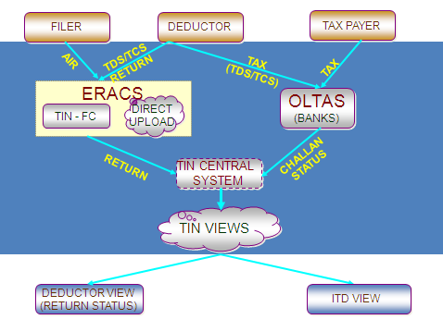

Implementation

ITD engaged NSDL (which had proven experience in handling a nationwide electronic transaction processing system) for establishing TIN.

This includes filing of an AIR with respect to specified high value financial transactions by certain specified entities.

Annual Information Return (AIR)

The Finance Act, 2003 inserted a new provision namely Section 285BA in the Income Tax Act, 1961 which was later on substituted by the Finance (No.2) Act, 2004 w.e.f. 01st April 2005. As per this provision, certain specified persons (hereinafter referred to as filers) are required to file AIR in respect of specified financial transactions registered or recorded by them during a financial year (beginning on or after 01stApril, 2004).

Specified Class of Persons required to file AIR and financial transactions to be reported in AIR

According to the amended provisions of Rule 114E of the Income Tax Rules, 1962 the nature of transactions and the threshold limit above which information has to be reported in the AIR by certain class of persons are as follows:

Sr. No. | Class of Persons | Nature and Value of transactions | Clarifications by Central Board of Direct Taxes vide Circular No.07/2005 dated 24thAug, 2005
1. | A Banking Company to which the Banking Regulation Act, 1949(10 of 1949), applies (including any bank or banking institution referred to in section 51 of that Act). | Cash deposits aggregating to ten lakh rupees or more in a year in any savings account of a person maintained in that bank | Only the aggregate of all the cash deposits in the savings account of a person to be reported as one transaction and the date of the transaction is to be the last date of the financial year i.e. 31.03.2005 in respect of FY 2004-2005.
2. | A Banking Company to which the Banking Regulation Act, 1949 (10 of 1949), applies (including any bank or banking institution referred to in section 51 of that Act) or any other Company or institution issuing credit card. | Payments made by any person against bills raised in respect of a credit card issued to that person, aggregating to two lakh rupees or more in the year. | Only the aggregate of all the payments by a person to the credit card company is required to be reported as one transaction and date of transaction is to be the last date of the financial year i.e. 31.03.2005 in respect of FY 2004-05.
3. | A trustee of a Mutual Fund or such other person managing the affairs of the Mutual Fund as may be duly authorized by the trustee in this behalf. | Receipt from any person of an amount of two lakh rupees or more for acquiring units of that fund. | The amount actually received from the transacting party and not the amount relating to allotment is to be reported
4. | A Company or institution issuing bonds or debentures. | Receipt from any person of an amount of five lakh rupees or more for acquiring bonds or debentures issued by the Company or institution. | The amount actually received from the transacting party and not the amount relating to allotment is to be reported.
5. | A Company issuing shares through public or rights issue. | Receipt from any person of an amount of one lakh rupees or more for acquiring shares issued by the Company. | The amount actually received from the transacting party and not the amount relating to allotment is to be reported.
6. | Registrar or Sub Registrar appointed under section 6 of the Registration Act, 1908 | Purchase or sale by any person of immoveable property valued at thirty lakh rupees or more. | There may be certain situations where the transaction in respect of property valued at thirty lakh rupees involves joint parties and value for one or more parties is less than rupees thirty lakh. In such situations, all such transactions are to be reported in respect of all the joint parties even though the value of transaction in the hands of one or more of the joint parties is less than the threshold limit.
7. | A person being an officer of the Reserve Bank of India constituted under section 3 of the Reserve Bank of India Act, 1934 who is duly authorized by the Reserve Bank of India in this behalf. | Receipt from any person of an amount or amounts aggregating to five lakh rupees or more in a year for bonds issued by the Reserve Bank of India. | The aggregate of all the receipts from a person is required to be reported as one transaction and the date of the transaction is to be mentioned as the last date of the financial year i.e. 31.03.2005 in respect of FY 2004-05.

Notes:

- The Central Board of Direct Taxes has vide Circular No. 07/2005 dated August 24, 2005 clarified that the persons filing the AIR should furnish only one return even if they have more than one branch. For example, a bank must file a single AIR covering all its branches.

- Transactions related to Kisan credit card should also be reported in AIR (refer Sr. No. 2 in above table).

Clarifications by Central Board of Direct Taxes vide Circular No. 07/2005 dated 24thAug, 2005 are given as Appendix 1.

AIR-Form and Periodicity

Form No. | Particulars | Periodicity | Last Date of Furnishing the Return
Form 61A (Part B) | Data in respect of specified high value financial transactions in specified file format (data structure). | Yearly | 31st August immediately following the financial year in which transaction is registered or recorded.
Form 61A (Part A) | Physical control chart containing control totals mentioned in Form 61A-Part B. | Yearly | With every AIR (Form 61A-Part B).

The forms are given in Appendix 2. These can also be downloaded from the ITD website (www.incometaxindia.gov.in) and the NSDL-TIN website (www.tin-nsdl.com).

Overview-Preparation and filing of AIR

In accordance with the provisions of the amended Section 285BA of the Income Tax Act, 1961 read with Rule 114E of the Income Tax Rules, 1962, certain specified entities (filers) are required to file AIR whereby they are required to report the details of certain prescribed high value financial transactions registered or recorded by them during the year.

AIR has to be filed annually in Form No. 61A (Part A & Part B).

Part A of Form No. 61A has to be filed in paper form, while Part B of Form No. 61A has to be prepared and filed on computer readable media being a floppy (3.5 inch and 1.44 MB capacity) or CD-ROM (650 MB or higher capacity) as per the file format (data structure) notified by the Director General of Income-tax (Systems).

Part B of Form No. 61A which has been prepared in accordance with the file format (data structure) notified by ITD has to be validated by the filer using the latest File Validation Utility (FVU).

The AIR prepared and validated using the latest FVU has to be filed with the TIN- Facilitation Centres (TIN-FCs) managed by NSDL
Note: Filers should file only one return for a financial year.

Preparation of AIR

Data Structure (File Format)

ITD has notified the file format (data structure) for furnishing of Original AIR vide Notification No. F.No. CIB/1/1/03-DIT (S) - 6809 dated 28th July 2005. The data structure is provided as Annex A.

File Format for the AIR consists of different record types. Each of the record type is explained below:

- File Header Record (FH): File header record type is the first line and contains the details relating to the AIR file.

- Batch Header Record (BH): It is the second line in the file. It contains details like name, address, TAN, PAN of the filer, name, father’s name and designation of person responsible for filing the form and the details with respect to the return like the total number of transactions, total value of transaction, date of filing, etc.

- Transaction Details Record (TD): It contains transacting party details like name, address and PAN details of transaction like mode, type, date and amount of transaction and the office address of the filer where transaction was undertaken. The number of TD lines in the return should be equal to the number of transactions mentioned in BH record.

Guidelines for Preparation of AIR

Before the preparation of the AIR, the filers are advised to go through the file format (data structure) mentioned above for better understanding and ease of preparation.

Guidelines given below should be followed while preparing the AIR:

Technical Guidelines for Preparation of AIR

- The file should be generated in ASCII Format with’txt’ as filename extension.
- The file name should not contain more than 12 characters (including .txt) i.e. the name of the file can be maximum eight characters long. The file name should not contain special characters ( /\ :*”?><_ Space & ^ ) e.g. the file name can be AIRN0405.txt
- The file should be a ‘carat (^) delimited’ variable width file. It means that in case of numeric fields no empty spaces or no leading ‘0’ be provided and in case of character fields no empty spaces or trailing spaces be provided.
- As the fields are delimited by ^, the character ‘^’ should not be used in any of the field.
- Each record (including last record) must start on the new line and must end with a new line character.
- The constant values as mentioned in the file format i.e. ‘Record Type’, ‘Upload Type’ must be mentioned in block letters only.
- Each line of a record type must contain details pertaining to that particular record type only.
- The sequence of the detail records must be in the order mentioned below:
--File header record (FH)
--Batch header record (BH)
--Transaction detail record (TD) (Number of transactions to be reported)
- In transaction detail record number (sr. no) field, the filer should enter unique running serial number for the transaction detail records in the return. Value should start from 1 and should be in sequence for all the transactions. In case of records pertaining to a joint transaction, it should have the same transaction detail record number for the particular joint transactions. Example: If there is only one transaction, which is a joint transaction of five joint holders, then the filer should enter the same transaction detail record number for each of the joint holders.
- The file should not contain any non-printable characters.

Operational Guidelines for Preparation of AIR

General
- One filer should file only one return for the whole financial year.
- One filer needs to file a single consolidated return in respect of all transactions pertaining to it including those done at any of its branches.
- Return should be filed only after the end of the relevant financial year. e.g. AIR pertaining to financial year 2008-09 can be filed only after March 31, 2009.
- Filer must provide an Indian address in the AIR.
- TAN must be quoted compulsorily by all the filers. If the filer is a non-government entity, TAN of the office of the principal officer of the person responsible for filing AIR must be mentioned.
- In case of Non-Government filer, it is mandatory to quote the PAN.
- Filer should verify that the TAN / PAN quoted are correct and actually belong to him. This may be verified on website – www.incometaxindia.gov.in
- Care should be taken while mentioning the transaction type (i.e. transaction code). Any error on this count may result into rejection during the validation of file.
- The code of the DIT (I & CI) having jurisdiction over the filer should be mentioned. Any error in this code may result into rejection during the validation of file.

Details of transacting parties – PAN
- In the field ‘PAN of the transacting party’ correct PAN should be written. If the PAN of the transacting party is not available, it should be left blank. For Government transacting parties, if the PAN furnished is structurally invalid then “INVALIDPAN” should be mentioned. However, for Non-Government transacting parties, “INVALIDPAN” should not be mentioned .
Note :- The file will be rejected if the words “INVALIDPAN” are mentioned for Non-Government transacting parties.
- In the Government / Non – Government Indicator field, the value should be ‘G’ (for Government transacting party) or ‘NG’ (for Non – Government transacting party). This field is mandatory, if the party does not have a PAN. If PAN is mentioned as INVALID, the value should be ‘G’ (for Government transacting party).
- In Form 60/61 indicator, value should be ‘Y’, if Form 60/61 is furnished and ‘N’, if Form 60/61 is not furnished.
- If the non-government transacting party does not have a PAN , Form 60/61 should be provided.. In case of government transacting parties who do not have a PAN, value should always be ‘NULL’ in Form 60/61 indicator.
- Form 60/61 indicator should be NULL if Structurally Valid PAN is mentioned for Government/ Non-Government transacting party or ‘INVALIDPAN’ is mentioned for Government transacting party.

Details of transacting parties – Name and address
- Full name of the transacting party should be mentioned in the return. It should be atleast three characters long and words like “Not Applicable”, “Not Available”, “NIL” should not be used.
- PIN code of the transacting party is mandatory. For foreign addresses (state code is ‘99’), it should be mentioned as ‘999999’.
- In case of cash deposit transactions (code 1), where name of party contains the words like Limited/Private Limited/ PVT/ PVT LTD/ PVT. / PVT. LTD./LTD. /LTD/ LIMITED/PRIVATE/ PRIVATE LIMITED/ private limited/limited, a warning message will be displayed by FVU.

Details of transactions – Amount
- Amount should always be reported in rupees (i.e. amount should be rounded off to the nearest rupee, paise must not be mentioned).
- Amount field should not be left blank except in the case of joint transacting parties, where the joint transaction party count is ‘zero’.
- There are certain types of transactions which should be aggregated for the purpose of reporting in AIR e.g. cash deposit transaction (code 1). For such transactions, all the transactions in respect of one party should be aggregated and reported as a single transaction. FVU may give a warning message if this is not followed.
- Transactions needs to be reported only if they are above the thresh-hold level prescribed for that type of transaction (e.g. in case of cash deposit transaction – code 1 – the aggregated value of the transaction for the whole year should be Rs. 10 lakh or above). FVU may give a warning message if this is not followed.
- The total value of purchase transactions (code 6) should be equal to total value of sales transactions (code 7), in return prepared by registrars / sub-registrars.

Details of transactions - Date
- Date of the transactions being reported should always be within the financial year for which the return is prepared. Date should always be written in dd-mm-yyyy format.
- Where the transaction is a joint party transaction where more than one parties are involved, the date of the transaction must be mentioned against the first holder and for the rest of the holders, the date should be left blank.

Reporting the transactions having multiple or joint parties
- In case of joint party transactions -
  - If the share of each of the joint holders is known, they should be treated as separate single party transactions. In such a case the transaction detail record number would be different for each party and the corresponding joint transaction party count would be ‘one’.
  - If the share is not known, then the filer should enter the number of joint holders against the first holder in the joint transaction party count field and for the rest of the joint holders, the value shall be ‘zero’. The first transacting party involved in a joint transaction will provide all the transaction details. The rest of the joint transacting parties will just provide the information that is unique to the transacting parties like Name, PAN, and Address fields etc. (in all the remaining fields in the transaction detail record no value should be specified).

- While reporting the joint party transactions, common information like date of the transaction, amount, transaction type, mode of transaction, transaction place etc. should be mentioned against the first party only. Name, PAN, Form 60/61 indicator, type of party (govt. or non govt.) and address should be mentioned for each party.
- In the field ‘Transaction detail record no. (Sr. No.)’ the same value should be mentioned against each joint party.
- In the field ‘Joint transaction party count’ number of parties involved should be mentioned against the first party only. For remaining parties, ‘0’ should be mentioned.

e.g.: How to report a transaction with 3 joint parties:

Transaction detail record no. (Sr. No.) | Joint transaction party count | Date of transaction | Name of the transaction party | Transaction code | Amount of transaction
1 | 3 | 31-03-2007 | x | 1 | 1000000
1 | 0 |  | y
1 | 0 |  | z

AIR Preparation Utility

Filers are free to use any software purchased from software vendors or developed in-house in order to prepare their AIR. A list of software vendors is also available on our website www.tin-nsdl.com. Alternatively, Annual Information Return Preparation Utility (A. I. RPU) can also be used for the preparation of AIR. This is freely downloadable on our website www.tin-nsdl.com

Important guidelines for using the Return Preparation Utility (RPU):

- No changes must be made in the format of the file. Some rows, columns and sheets that are hidden/protected must not be un-hidden/unprotected.
- The filer must avoid cut/copy and paste data from other sources in the file as this may result in loss of validations/formulae/formatting provided for the cells.
- Wherever dropdown list has been provided for any column, the value should be picked from that given list only.
- Date should always be entered in dd-mm-yyyy format. It should not exceed the current date.
- The filer should not start working in the RPU by opening it from the website. The RPU should be saved at some location in the PC, before one starts working in it.

NSDL-RPU can be effectively used to prepare AIR where the number of transacting party records does not exceed 30,000.

Validation of AIR using File Validation Utility (FVU)

After preparing the AIR, verify its format level accuracy using the latest File Validation Utility (AIR-FVU).

AIR–FVU has been developed by NSDL for filers to ensure that the AIR prepared by them conforms to the prescribed file format. After preparing the AIR, the filer must validate the return using AIR-FVU to ascertain whether the return contains any format level error(s). In case the filer finds any error(s), he should rectify the error(s) and pass the file again through the AIR-FVU. The filer shall repeat this process until he gets an error free return. It should be noted that the FVU validates only the format level accuracy of the AIR.

It must be further noted that an AIR, which has not been validated using the latest FVU, will not be accepted at any TIN-FC AIR, irrespective of software used for its preparation, has to be validated through latest FVU.

AIR–FVU is freely available at NSDL-TIN website (www.tin-nsdl.com) under ‘downloadables’ section.

Installation of AIR FVU

Pre-requisite

JRE (Java Run-time Environment) [versions: SUN JRE: 1.4.2_02 or 1.4.2_03 or 1.4.2_04 or IBM JRE: 1.4.1.0] should be installed on the computer where the AIR FVU is being installed.

JRE is freely downloadable from http://java.sun.com or http://www.ibm.com/developerworks/java/jdk or you can ask your computer vendor to install the same for you.

FVU can be executed on any of the Windows platforms mentioned below:
Win 2K Prof./ Win 2K Server/ Win NT 4.0 Server/ Win XP Prof.

Procedure for installation of AIR FVU
Copy AIR FVU.exe and AIR FVU Extract Readme.rtf available on NSDL-TIN website (www.tin-ndsdl.com) to any desired location of your PC.
AIR FVU Extract Readme.rtf is a document containing the procedure for installation of AIR FVU.

Steps for installation of AIR FVU:-

A) Click on ‘AIR FVU.exe’.

B) A window ‘WinZip Self-Extractor – AIR FVU.exe’ will open as displayed below.

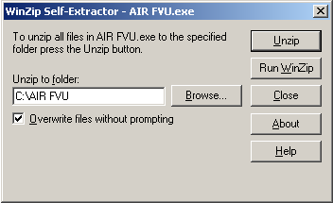

AIR FVU contains the following three files:

AIR FVU Setup Readme.rtf: This file contains instructions for setup of the AIR FVU.
AIR FVU Setup.exe: This is a setup program for installation of FVU.
AIRFVU.jar: This is the FVU program file.

By default the path selected for extraction of the three files will be ‘C:\AIR FVU’.

The files can also be extracted in any other location (other than C:\AIR FVU). In that case define appropriate path by clicking the ‘Browse’ button where the three files should be extracted.

Thereafter, click on ‘Unzip’ button. On clicking the ‘Unzip’ button the three files mentioned above will get extracted to the specified path (i.e. in folder ‘C:\AIR FVU’ by default or at the specified path).

After extraction is complete, a message that files have been unzipped succesfully will be displayed. Click on ‘OK’ button.
Click on ‘Close’ button to exit the extracting program.

C) Click on the ‘AIR FVU Setup.exe’ icon located at the path selected for extraction of the files (if no path was specified at the time of extraction then it will be located at the default path ‘C:\AIR FVU’).

The ‘AIR FVU Setup.exe’ will search for JRE on the computer. If it is unable to locate the JRE at the required location (Registry) then a dialogue box will open as displayed in figure 1.

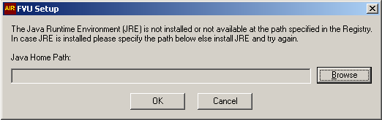
Figure 1

- If JRE is not installed on your computer then click ‘Cancel’. Install appropriate version of JRE (specified above) and try again by clicking ‘AIR FVU Setup.exe’.

- If JRE is installed on your computer (but the AIR-FVU setup could not locate it) and you know the path where JRE is installed, specify the JRE home path in the field ‘Java Home Path’ by selecting the ‘Browse’ button, as displayed in figure 2.

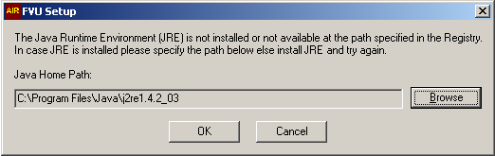
Figure 2

- Thereafter click ‘OK’. ‘AIRFvu.bat’ will be created at the location where ‘AIR FVU Setup.exe’ is present. (Note: ‘AIRFvu.bat’ will be created even if incorrect JRE home path is given or path specified even if JRE is not installed but it will be non-functional).

JRE found by ‘AIR FVU Setup.exe’

If appropriate version of JRE is found on the computer then on clicking ‘AIR FVU Setup.exe’ a ‘AIRFVU.bat’ file will be created at the location where ‘AIR FVU Setup.exe’is present.

Using AIR FVU

Click on the ‘AIRFVU.bat’ file to start using AIR FVU.

A window will open as shown in Figure 3:

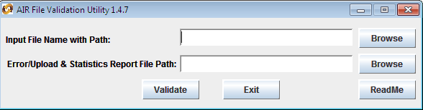

Figure 3

Procedure for validation of AIR using FVU

As displayed in figure 3 above, the input screen of the FVU has two fields viz. ‘Input File Name with Path’ and ‘Error/Upload and Statistics Report File Path’.

      - Input File Name and Path

- Click on the browse button against “Input File Name with Path:” and select the AIR file prepared as per file format, to be validated by the FVU.
- Input filename should not be more than 12 characters (including the .txt extension) and should not contain any special characters eg. : , \ / etc.
For example file name can be AIR0405.txt

NOTE: The ‘Input File’ needs to be a text file i.e. with extension ‘txt’.

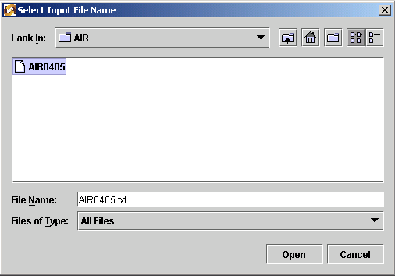
Figure 4

In the example above (Figure 4) the ‘Input File Name’ chosen is AIR0405.txt.

      - Error File/Upload and Statistics Report Path
- Click on the browse button against ‘Error/Upload and Statistics Report File Path’ and specify the path where an ‘Error file/ Upload and Statistics Report’ that is generated by the FVU on completion of validation of the return should be saved. The path can be same as the input file path or different. Do not specify any filename, only provide the path. If nothing is selected here with output file will be created by default at the location where the input file is available.

In case the input file is invalid, the FVU will indicate that error(s) were found during validation and shall specify the path where the error file is generated. (Figure 5)

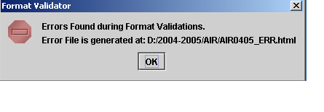
Figure 5

AIR0405_ERR.html is an ‘Error’ file generated in html format with the same filename as the input file with _err appended after the file name and html as extension (figure 6). Example, for the input file name AIR0405.txt; the error filename will be ‘AIR0405_ERR.html’. The error file will contain details of erroneous records like line number, record type, batch number, TD record number, along with the error code and the corresponding error description. The line numbers of the records in the error file will be the line number in the input text file.

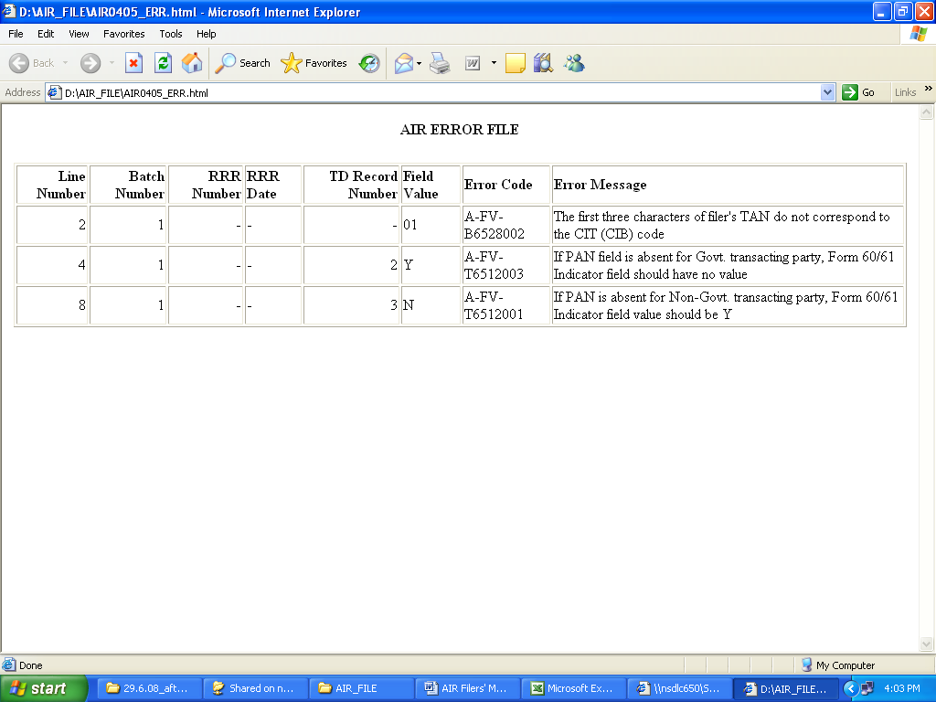
Figure 6

In the figure given above, error message indicates that there are errors in line numbers 2, 4 and 8. The TD Record Number against line number 2 is blank as this line pertains to Batch Header. The filer will have to rectify the error(s) in the input file and validate the return again through the FVU.
This cycle is repeated till the file provided as input file in free of all errors.
Only after a valid file is provided as input file, the FVU will indicate that the file validation is successful and shall specify the path where Upload and Statistics Files are generated. (Figure 7)

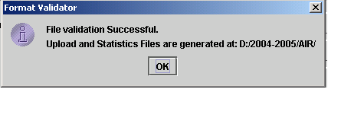
Figure 7

Upload and Statistics Files that are generated :-
- ‘AIR Statistics Report’: e.g. AIR0405.html
- ‘AIR Filer Details’” e.g. AIR0405_details.html and
- ‘Upload file’: e.g. AIR0405.fvu.

AIR0405.html is a ‘AIR Statistics Report’ (figure 8) which is a summary of the AIR successfully validated by the FVU. It also contains list of transacting party PAN details like number of missing PAN, number of Invalid PAN.
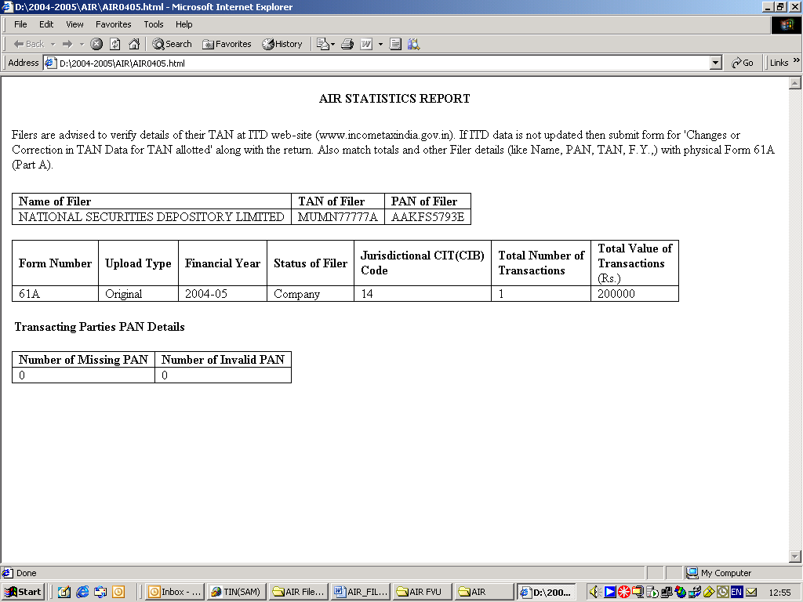
Figure 8

AIR0405_details.html (figure 9) contains AIR Filer Details and Details of Transacting parties as entered by the filer with the potential discrepancies, if any.

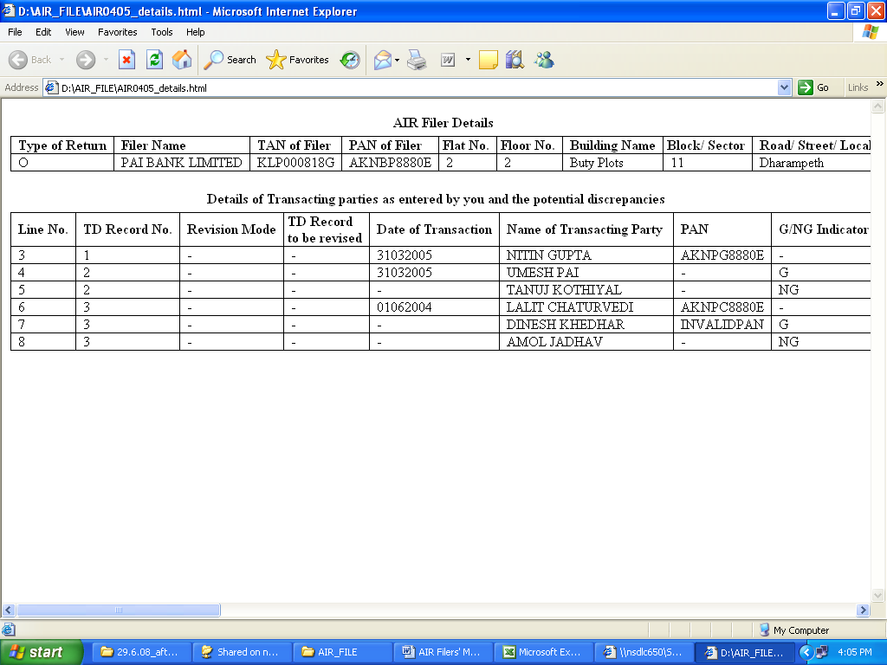
Figure 9

AIR0405.fvu is an ‘upload file’ generated with the same filename as the ‘input file’ but with extension .fvu. Example for ‘input file’ AIR0405.txt, the upload file generated will be AIR0405.fvu.

The upload file generated by the FVU (AIR0405.fvu) is a structurally valid return containing a value generated by the FVU, which indicates that the return has been successfully validated through the FVU.

In case the filer wishes to modify its AIR after successfully validating it through the FVU, it shall modify the file that it selected as ‘Input File’ and validate it again through the FVU.

No modifications should be made in the upload file. (i.e. the file with “.fvu” extension.

The upload file (with extension .fvu) is to be submitted to a TIN-FC in a CD/floppy along with physical Form 61A (Part A)-

Preparation of Form No. 61A (Part A)

Form No. 61A (Part A) has to be filed in physical form with Form No. 61A (Part B) which has to be furnished electronically.

The filer should ensure that the form is properly filled-in and verified as per the instructions prescribed in the form. Special care may be taken on the following:
- Folio Number of the person: In this column, the filer should mention the Tax Deduction and Collection Account Number (TAN). If the filer is a Government entity, the TAN of the filer should be mentioned and in case the filer is a non-government entity, the TAN of the office of the principal officer of the person responsible for filing AIR must be mentioned. In case the filer does not have a TAN, it should first obtain the same by applying, using the latest Form 49B (notified by ITD in December 2004) through any TIN-FC-

- Permanent Account Number: It must be ensured by the filer that the Permanent Account Number (except in case of Government departments) is mentioned in Form No. 61A (Part A).

Control Totals
- Total number of transactions reported in the AIR: In this column, care should be taken by the filer to ensure that the figure reported is the same as mentioned in the Form No. 61A (Part B).

- Total value of all transactions reported in the AIR: In this case the value of transactions reported in Form No. 61A (Part B) should match with the value mentioned in this column.

Furnishing of AIR

Furnishing of AIR through TIN-FC

NSDL has established a network of TIN-FCs that receives AIR from the filers. The filers shall furnish their AIR at any of these TIN-FCs. NSDL keeps on appointing TIN-FCs at different locations all over the country on a continuous basis. The updated list of TIN-FCs is available at www.tin-nsdl.com

After preparing and validating the AIR, the filer shall furnish the same at any TIN-FC managed by NSDL.

The filer shall ensure that:

- The AIR is accompanied by a duly filled and verified (by an authorized signatory) Form 61A (Part A) in physical form.
- The AIR is in one CD/floppy and not spanning across multiple floppies/CDs.
- The AIR is compressed, if required, only by using WinZip 8.1 or ZipItFast 3.0 (or higher version) compression utility to ensure quick and smooth acceptance of the file.
- Label mentioning the folio no. (TAN), name of the filer, period to which the return pertains (F.Y.), PAN (except Government filers) is affixed on the CD/floppy for the purpose of identification.
- There is no overwriting/striking on Form 61A (Part A). If there is any, then the same is ratified by an authorized signatory.
- TAN and PAN of the filer are mentioned in the AIR. Only in case of Government filer, PAN need not be mentioned. In case the filer does not have a TAN, it should first obtain the same by applying, using the latest Form 49B (notified by ITD in December 2004) through any TIN-FC
7. The AIR has been successfully passed through the latest version of the FVU.
8. Control totals, TAN and name mentioned in the AIR match with those mentioned on Form 61A (Part A).
9. CD/floppy is virus free.

Acceptance of AIR

Acceptance of AIR by TIN-FCs

After the filer furnishes the AIR to TIN-FC in the manner prescribed in Chapter 4, TIN-FC will carry out the format level validations (these validations are same as performed by FVU) and other checks to validate the AIR.

In case the AIR is valid TIN-FC will issue a Provisional Receipt to the filer. The Provisional Receipt issued by TIN-FC to the filer is deemed to be the proof of AIR furnished by the filer.

The filer will pay the upload fees along with service tax as applicable to the TIN-FC.

Charges payable for accepted returns *:

Number of Transacting parties | Upload fees#
Upto 100 transacting parties | Rs. 35.00
101 to 1000 transacting parties | Rs. 178.00
More than 1000 transacting parties | Rs. 578.50
#excluding tax

*No fee will be charged for AIR that is not accepted.

The TIN-FC will retain the CD/floppy containing the AIR and physical Form 61A (Part A). The retained CD/floppy along with other documents, if any, shall be forwarded to ITD at a later date by the TIN-FC.

5.2 Non-acceptance by TIN-FCs

TIN-FC will not accept the AIR furnished by the filer if:

- The AIR is not furnished in a CD/floppy along with duly filled and signed
Form 61A (Part A) in physical form;
- Striking and overwriting, if any, on Form 61A (Part A) are not duly ratified by the person who has signed Form 61A (Part A);
- The filer has not mentioned its Name, TAN, Form no. or period to which return pertains (F.Y.) on the CD/floppy for identification purpose;
- The AIR is compressed using a compression utility other than WinZip 8.1 or ZipItFast 3.0 (or higher version) compression utility;
- The AIR is not in conformity with the file formats prescribed by Income Tax Department;
- The filer has not stated its TAN;
- Non-Government filer has not stated its PAN;
- Mismatch of control totals generated by Online SAM¹ with Form 61A (PartA);
- The AIR has not been successfully passed through the latest version of FVU.
- The AIR does not pertain to the period for which the filers are allowed to submit their returns.
- CD/floppy is not virus free.
- TAN stated in the AIR is not present in Online SAM¹ and the filer does not submit any proof of TAN stated in the return;
- Name/address of the filer displayed on Online SAM¹ does not match with name/address stated on Form 61A (Part A) and the filer does not provide any proof of TAN change request.
- Any other reason.

In such cases, TIN-FC shall issue a Non-Acceptance Memo to the filer to carry out necessary corrections. The Non-Acceptance Memo contains the possible reason for non-acceptance.

In case of non-acceptance, TIN-FC shall return the CD/floppy, any other documents furnished. The physical Form 61A (Part A) shall be retained by the TIN-FC.

No fee will be charged for the AIR that is not accepted.

Online SAM – Online Statement Acceptance Module is web based interface provided by NSDL e-Gov to TIN-FCs for accepting the returns furnished by the filers.

TIN Call Centre (TCC)

If you need any assistance or clarification, please contact TIN Facilitation Centres near your location. You may also contact the TIN Call Centre (TCC) at:

NSDL e-Governance Infrastructure Limited
5th Floor, Mantri Sterling
Plot No. 341, Survey No. 997/8, Model Colony
Near Deep Bungalow Chowk, Pune – 411 016
Tel: 020 – 2721 8080
Fax: 020 – 2721 8081
Email: tininfo@nsdl.co.in

Working hours:
9.30 A.M. to 8.00 P.M. – Monday to Friday
9.30 A.M. to 6.00 P.M. – Saturday

Address of NSDL e- Gov Regional Offices

Ahmedabad Chennai
Unit No. 407, 4th floor, 6A, 6th Floor, Kences Towers
3rd Eye One Commercial Complex, 1 Ramkrishna Street
Near Panchvati Circle, North Usman Road
C.G. Road, Ahmedabad – 380006 T. Nagar, Chennai – 600017
Tel: (079) 2646 1376
Fax:(079) 2646 1375 Tel: (044) 2814 3917/18
Fax: (044) 2814 4593
Email: dilips@nsdlc.o.in Email: npoochelvam@nsdlc.o.in

Kolkata New Delhi
5th Floor, The Millenium, 409/410, Ashoka Estate Building
Flat No. 5W, 235/2A, 4th floor, Barakhamba Road
Acharya Jagdish Chandra Bose Road, Connaught Place
Kolkata - 700020 New Delhi 110 001.
Tel: (033) 2281 4661/62 Tel: (011) 2335 3815/17
Fax: (033) 2289 1945 Fax: (011) 2335 3756
Email: sandeepanm@nsdl.co.in Email: nitinj@nsdl.co.in

Checklist for the filer

After preparing the AIR, the filer should check following to ensure that the AIR is complete in all aspects and is ready for furnishing to TIN-FC:
- AIR is in conformity with the file format notified by ITD.
- AIR is furnished in a CD/floppy along with duly filled, signed and verified Form 61A (Part A) in physical form.
- Form 61A (Part A) is duly filled and signed by an authorized signatory.
- Striking and overwriting, if any, on Form 61A (Part A) are ratified by the person who has signed Form 61A (Part A).
- More than one CD/floppy is not used for furnishing the AIR.
- Label is affixed on CD/floppy containing details of filer like name of filer, TAN, form no. and period to which return pertains.
- AIR if compressed, is compressed using WinZip 8.1 or ZipItFast 3.0 compression (or higher version) utility only.
- TAN quoted in the AIR and stated on Form 61A (Part A) is the same. Confirm TAN by using search facility on ITD website (www.incometaxindia.gov.in).
- If there is any discrepancy in the details of TAN (name, address) displayed in the ITD website and in the details of TAN mentioned by the filer in the AIR, apply TAN change request using Form for changes or corrections in TAN Data for TAN allotted to update the ITD TAN database.
- Carry copy of TAN allotment letter from ITD or screen print from ITD website as proof of TAN to avoid inconvenience at time of furnishing the return.
- Control totals, TAN and name mentioned in AIR match with those mentioned on Form 61A (Part A).
- The AIR has been successfully passed through the latest version of FVU and the hash file is presented to TIN-FCCD/floppy furnished is virus free.

For updated information/latest version on topics covered above, please visit our website www.tin-nsdl.com
---------

